
Etumos Framework

Nurture Architecture Documentation

Modification History

Table of Contents
Table of Contents
Nurture Architecture Components Overview
Nurture Qualification Management Program
Nurture Qualification Management Setup
Nurture Prioritization Segmentation
Creating and Ranking Segment Values
Engagement Programs
Nurture Cast Programs
Steps for Creating a New Engagement Program
Framework Record Processing Example

Nurture Architecture Components Overview
There are four components of Etumos nurture architecture. These interconnected components ensure that leads are routed to the best fit engagement program while eliminating audience overlap.
Nurture Qualification Management Program - a centralized operational program that manages qualification for all engagement programs in the instance. To accomplish this, the program influences the Nurture Prioritization Segmentation by adding leads to “Qualified” static lists that correspond to each engagement program.
Marketo Link
Nurture Prioritization Segmentation - a segmentation that identifies the best fit engagement program within the instance. This segmentation contains a segment value for each engagement program. Leads qualify for each segment based on membership in Nurture Qualification Management “Qualified” static lists. The segmentation order determines priority for those qualified for multiple nurtures.
Marketo Link
Engagement Programs - all engagement programs in the instance observe changes to the Nurture Prioritization Segment to Add and Pause leads in their respective nurtures. No target audience criteria or data value change triggers exist within individual engagement programs.
Find all links in the Intercom Nurture Qualification Workbook
Nurture Cast Programs - programs nested within engagement program streams that manage exclusions and send the nurture emails.
Below is a diagram that demonstrates how the individual pieces of nurture architecture work in tandem to ensure leads are nurtured by the best fit engagement program within the instance.
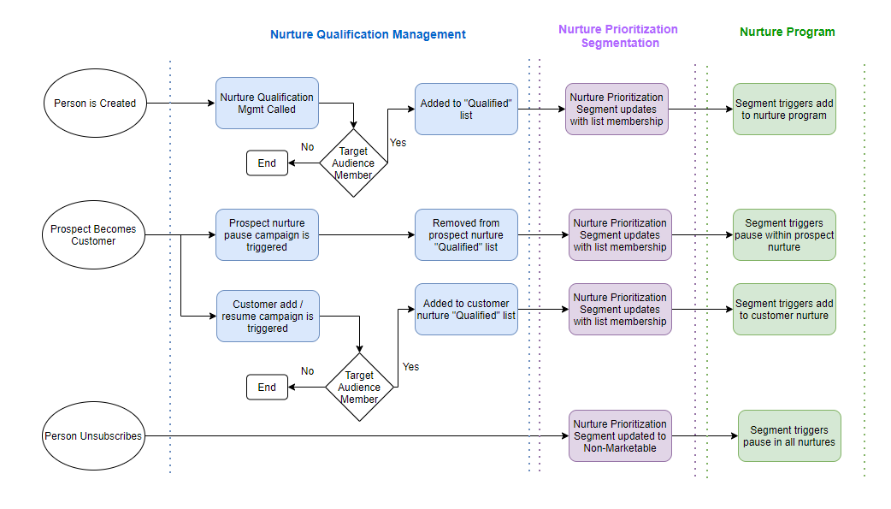

Nurture Qualification Management Program
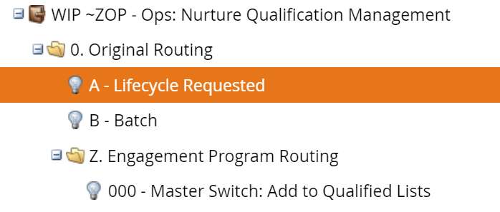
Nurture Qualification Management is a centralized operational program that manages nurture qualification for all engagement programs in the instance. To accomplish this, the program influences the Nurture Prioritization Segmentation by adding leads to “Qualified” static lists that correspond to each engagement program the person qualifies for.
All leads are evaluated against each engagement program’s target audience criteria at the time of creation via Lifecycle Processing. Once the lead has entered the Nurture Qualification Management program, the “000 - Master Switch: Add to Qualified Lists” campaign is called. This campaign evaluates which “Targeting” smart lists they are members of and adds the lead directly to each “Qualified” static list they qualify for.

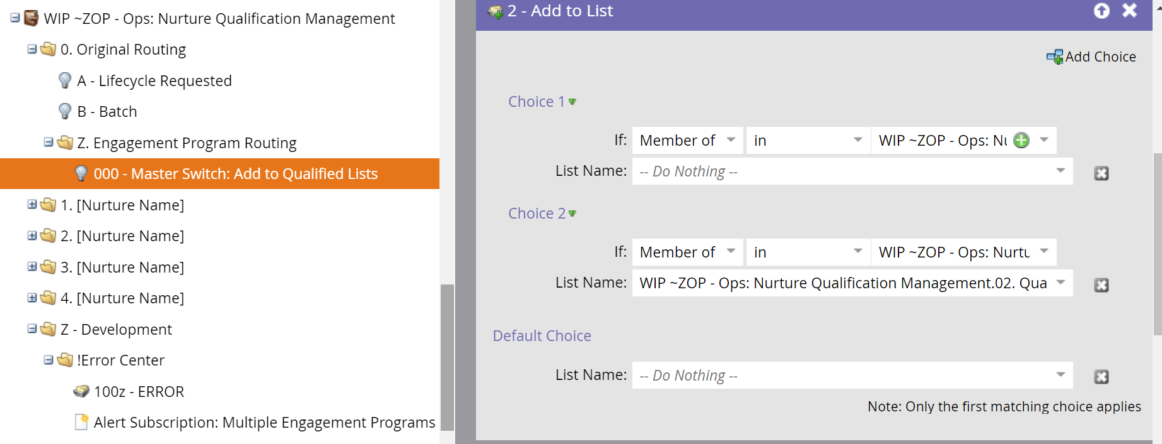
It is possible for leads to end up in multiple “Qualified” static lists if they meet target audience smart list criteria for multiple engagement programs. Prioritization of the “Qualified” static lists within the Nurture Prioritization Segmentation ultimately determines which engagement program the lead will be nurtured by.

Nurture Qualification Management Setup
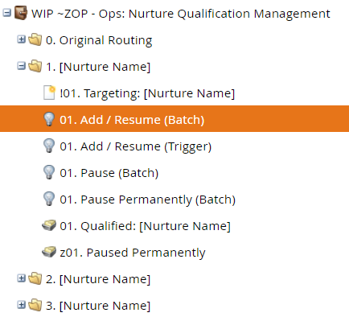
Each engagement program in the instance must be accounted for in the Nurture Qualification Management program and will have a dedicated folder created to support it.
Each engagement program folder will contain campaigns for “adding to” and “pausing", as well as “Qualified” and “Paused Permanently” static lists. They will also include a “Targeting” smart list that defines the criteria of qualification for the nurture.
These campaigns add and remove leads from “Qualified” and “Paused Permanently” lists, and thereby make leads eligible (or ineligible) for nurture by a specific engagement program.

Each dedicated nurture folder will contain both a Batch and Trigger “xx. Add / Resume” campaign.While both campaigns can be configured, we typically recommend only utilizing one of the two processes.

The batch version evaluates records against the nurture’s targeting smart list as well as the “Pause Permanently” and “Qualified” static lists on a scheduled cadence. If the record meets the targeting criteria and is not a member of either static list, the record is added to the “Qualified” static list.

Note: that if you are using the batch Add / Resume campaign and only want to include records moving forward after program launch you will want to add a created date filter to the “Targeting” smart list.

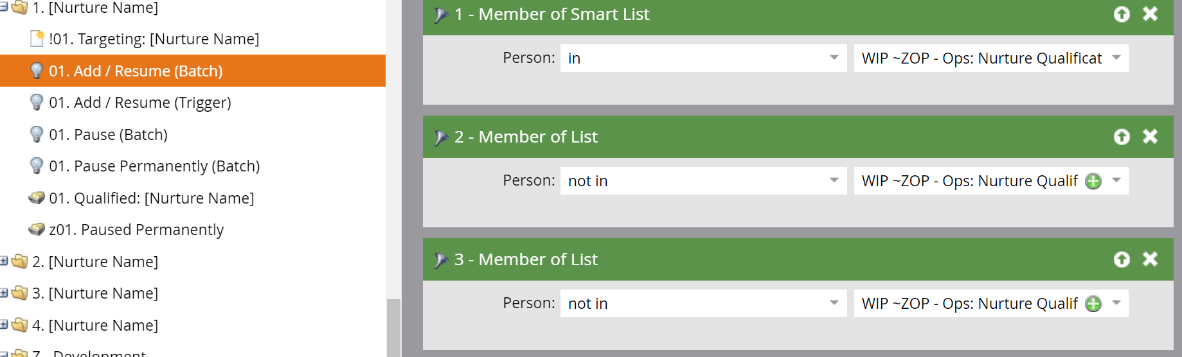

The triggered version of the Add / Resume campaign works in a similar fashion but is triggered in real time by defined data value changes or other triggers. If a triggered action results in the record meeting the targeting criteria for the nurture they are added to the “Qualified” static list.

Note: that if only using the triggered Add / Resume campaign on an on-going basis the batch version of the campaign can still be run one time to backfill existing records onto the “Qualified” static list.
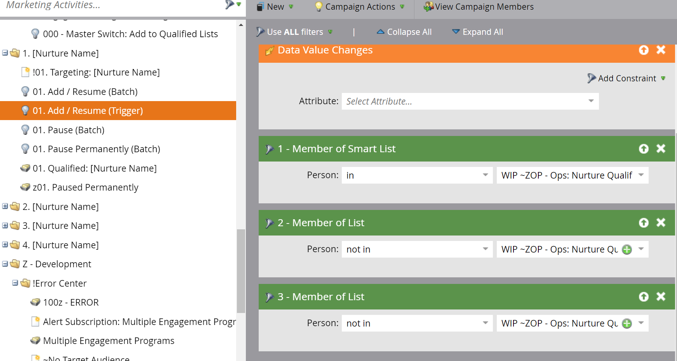

The “xx. Pause (Batch)” campaign is a recurring batch campaign that evaluates records currently on the “Qualified” static list for a given nurture against that nurture’s “Targeting” smart list. If the record no longer meets the targeting criteria for the nurture, they are removed from the “Qualified” static list. This will in turn update the Nurture Qualification Segmentation of the record.

The “xx. Pause Permanently (Batch)” campaign is another recurring batch campaign. This listens for a record to exhaust content in their current Engagement Program..

Note: that the “Exhausted Content” activity will not be logged until a cast is attempted and no additional content exists in the stream.

Once the batch campaign executes and the record has the exhausted content activity logged, the record is removed from the “Qualified” list and added to the “Paused Permanently” list for the given nurture. If currently active in the engagement program, this will result in the record being paused in the current Engagement Program (as the nurture prioritization segmentation will be recalculated) and being added to the next most highly prioritized nurture that they are qualified for.

In this way, all engagement program qualification triggers and audience criteria are managed centrally within the Nurture Qualification Management program.
Note: It is important that the local Add, Pause and Resume Nurture smart campaigns are active in the Engagement Programs prior to finalizing the Nurture Prioritization Segmentation. The actual addition of records to the Nurture Prioritization Segmentation is completed by adding records to the appropriate “Qualified” static list and approving the segmentation. These two steps can be completed in either order, but the local Engagement Program campaigns must be activated prior to completing whichever step is last.

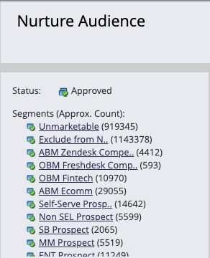
Nurture Prioritization Segmentation
The Nurture Prioritization Segmentation is used to identify 1) records that are not eligible for nurture 2) the best fit (most highly prioritized) nurture within the instance for records that meet the nurtures qualification criteria and are added to the “Qualified” static list 3) to highlight which marketable records are not being nurtured (shown in the default segment).
Suppression segments (ex//: Non-Marketable) are used to restrict records that are not eligible for nurture. These should live at the highest priority within the segmentation. Examples include “Non-Marketable”, “Not Subscribed” and “Employees”.

Next in priority are the Active Nurture segments (ex//: LN - 2018 Gartner MQ Nurture). The Segment logic for each engagement program is simple, as it only requires the lead to be a member of the corresponding “Qualified” static list managed within Nurture Qualification Management program. Due to the nature of Marketo Segmentations, a person can only exist in one segment at a time. If a lead meets the criteria for more than one segment (ex//: Is in multiple “Qualified” static lists), it will be assigned the highest prioritized segment value.

Finally, all records that are marketable but are not currently a member of a “Qualified” static list will fall into the “Default” segment. Analyzing members of the “Default” segment is a good way to understand what sections of your database may benefit from additional engagement programs.
By using the Nurture Prioritization Segmentation to inform active engagement program membership, we are able to ensure mutually exclusive engagement program audiences. However, this requires all engagement programs in the instance to observe the Nurture Prioritization Segmentation (unless audience overlap between engagement programs is desired).
There are instances where it may be necessary to build an engagement program outside the Nurture Prioritization Segmentation to ensure audience overlap. A common example of this is Trial or other nurture programs that contain timebound operational emails.

Creating and Ranking Segment Values
When creating additional engagement programs and adding them to the Nurture Prioritization Segmentation, the order/priority of the newly created segment is important because it impacts the priority of one engagement program relative to others.
For this reason, the order of the segments should be in line with how you would like to prioritize membership in engagement programs. For example, a Customer or later funnel stage engagement program should be more highly prioritized than a lower funnel stage (MAL/MQL) engagement program.

By assigning Non-Marketable and Not Subscribed segments the highest priority, it assures that a person who becomes Unsubscribed is transitioned to the Non-Marketable Segment.

Engagement Programs
Engagement programs in the instance should all observe changes in the Nurture Prioritization Segmentation, with the exception of trial/operational engagement programs as noted previously. Each of the smart campaigns within the engagement program will be triggered by a Nurture Prioritization Segment change. Since the audience criteria and logic for pausing and resuming nurture exist in the centralized, operational Nurture Qualification Management program, the logic within the engagement program is very straightforward.

When the Nurture Prioritization Segment changes to the value associated with a given program and the record is not already a member of the Nurture, the campaign 01 - Add to Nurture adds the record to the program. The flow step of this campaign should be used to route new people into the appropriate stream.

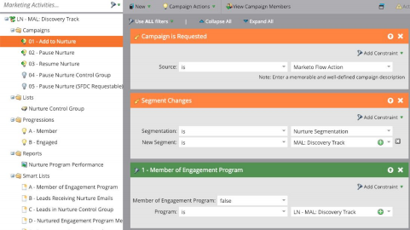
If a record is already a member of the program and Nurture Prioritization Segment is changed to any value other than the one associated with the given program, 02 - Pause Nurture changes the program cadence to “Paused”. This means that the record will remain in the same position in the Nurture Stream but will not receive any additional emails from the program.

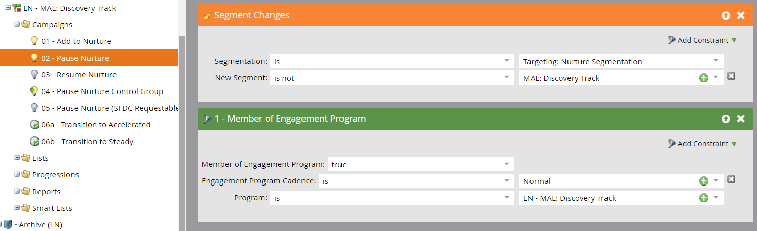
If a record has been paused in the program previously, and the Nurture Prioritization Segmentation is changed back to the value associated with the given program 03 - Resume Nurture updates the program cadence from “Paused” to “Normal”. This results in the record resuming in the Nurture Stream. At the next scheduled cast, they will receive the piece of content highest in the stream that they have not already received.
We recommend managing stream transitions by using smart campaigns local to the engagement program rather than using the out of the box transition rules in the nurture streams. This provides more clarity when viewing the engagement program transitions as results can be viewed.

Nurture Cast Programs

Nurture Cast programs are nested within engagement program streams to deliver individual nurture emails. Nested programs are preferred to nested emails in streams for four main reasons.
1) Programs allow us to set a program member status of “Exclusion” for leads who should not be exposed to a particular piece of content. All members of a nested program in an engagement stream will be skipped and will not receive a given piece of content. They will instead go on to receive the next piece of content in the stream, assuming they are not a member of that program also. Setting the status of “Exclusion” for leads who have already consumed a piece of content is a useful feature for ensuring that a touch is not wasted by promoting the same piece of content to someone that has previously consumed it.

2) The smart campaign in a nested program makes it very easy to test and send multiple email variants using Random Sample.

3) Program success statuses in nested nurture cast programs allow us to perform Marketo program performance reporting and associated SFDC reporting when desired. They also allow us to trigger off of nurture cast program status changes to inform Engagement Program success criteria and stream transitions.

4) Program tokens within the nurture cast program template speed up the time it takes to build and activate a new nurture email.
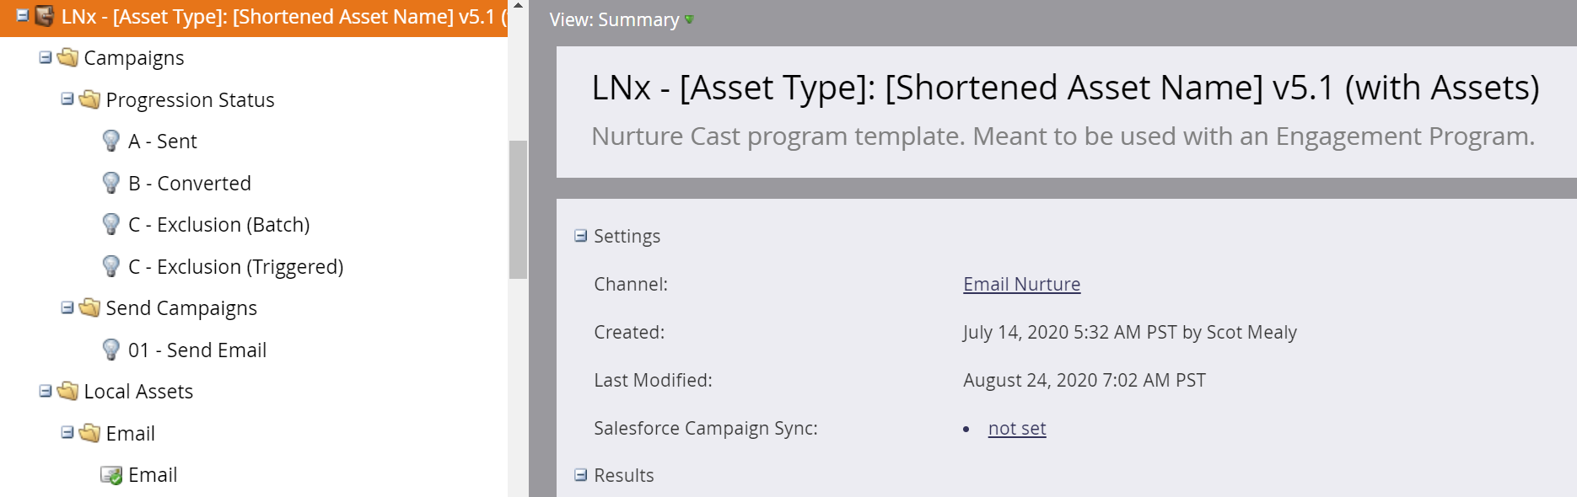

Nurture Cast programs are easily cloned and can be built by simply updating the program tokens and performing a quick QA. Program status progressions are pre-configured and can be activated in a matter of seconds. Exclusion status campaigns can be configured in a matter of minutes.

Steps for Creating a New Engagement Program
Below are the steps required for building a net new engagement program.

1) Create a folder, or dedicate an existing folder in Nurture Qualification Management to the new engagement program. Make sure all the necessary assets exist, using the existing folders for reference.
2) Add a value to the Nurture Prioritization Segmentation to represent the new engagement program. Make sure the new value is correctly prioritized. Reference the dedicated “Qualified” static list in Nurture Qualification Management to define the logic for this segment and approve the segmentation.
3) Clone the Engagement Program template into a new dedicated folder. This folder will house the Engagement Program and all nested Nurture Cast programs. Update the segment change trigger in the engagement program smart campaigns to reference the new Nurture Prioritization Segment value and activate the Add, Pause, and Resume campaigns. Configure the Progression campaigns to reflect your success criteria before activating them. Configure streams, stream cadence, and transition rules as you would for any engagement program.
4) Clone the Nurture Cast Program template for each piece of stream content. These programs can be housed in a subfolder below the dedicated engagement program folder. Each Nurture Cast program email can be quickly configured by updating the program tokens and updating the text-only version of the email. Check that the email(s) to be sent are referenced by the correct send email and progression campaigns. Schedule the pre-configured progressions campaigns. Exclusions campaigns should be configured as necessary. Once email and program QA is complete, drag/add the send email smart campaign into the engagement program stream and activate the content. Click on the ‘Send Email’ smart campaign once it’s been added to the nurture stream and a green arrow will appear, confirming that the send email campaign is active (see image below).

Traditional User Interface view (left) & MEUE view (right) of active stream content
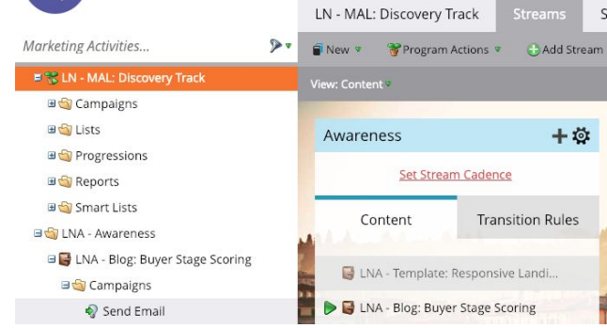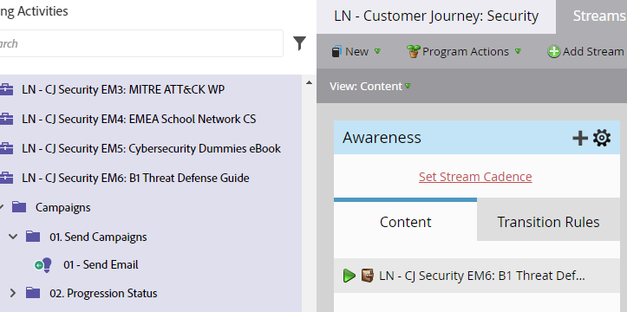

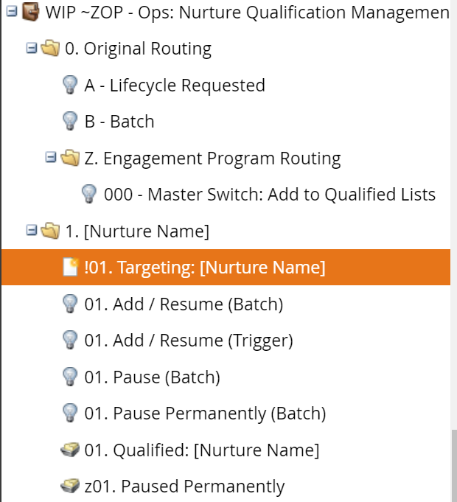
5) Next, within the Nurture Qualification Management program configure a dedicated “Targeting” audience smart list located within the dedicated nurture folder. Configure the smart list to define the audience criteria for your engagement program. Filters should exist for all for inclusion/exclusion requirements. If it’s necessary to create a new Target Audience smart list, ensure that a reference to it is added to the “~no Target Audience” smart list in the Z - Development > !Error Center folder. You will also want to create new Audience Overlap Audit smart lists for the new nurture (and update the other smart lists) to account for this new Target Audience smart list.

6) Within the dedicated Nurture Qualification Management folder, configure the smart campaigns. Determine if you will use the batch or trigger version of the Add/Resume campaign. If using the triggered version, the Add/Resume campaign should be updated with any triggers that should cause a lead to be re-evaluated to determine if it should be included in the new engagement program. If using the batch version the campaign should be scheduled to run on a recurring basis in line with the Nurture Stream send cadence. The Pause campaign should also be configured as a recurring batch. It shouldn’t be necessary to add additional filters since the smart campaign should already reference the Targeting smart list.
Once you activate the appropriate ‘LN: Add / Resume Nurture’ smart campaign existing leads will start being added to your engagement program. This is because the Nurture Prioritization Segment is already watching for membership in the list that this campaign updates and the engagement program itself should already be watching for Nurture Prioritization Segment updates. Do not activate this campaign until you’re ready to start adding leads to your engagement program and do not activate it until you have configured and approved both the Nurture Prioritization Segmentation and the engagement program.
7) To ensure that newly created leads are evaluated to qualify for your new engagement program, add an Add to List flow step to the ‘000 - Master Switch: Add to Qualified Lists’ campaign. This flow step should add leads directly to the ‘Qualified” static lists for the new Engagement Program if they are not currently members of that nurture’s “Paused Permanently” list . See screenshot below.
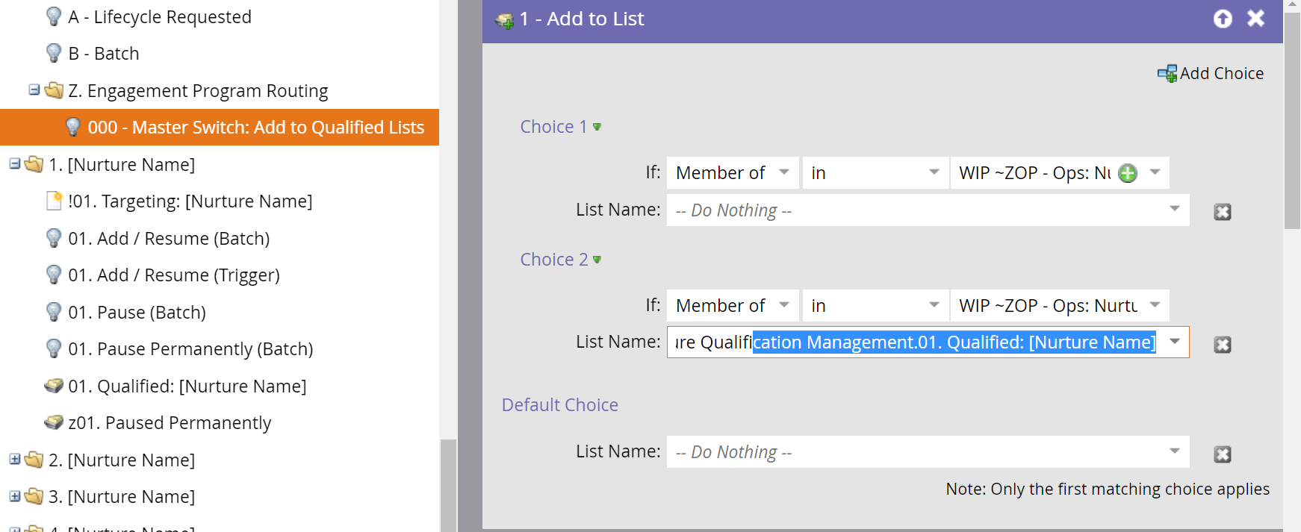

8) Finally, you’re ready to test. Test that a newly created lead qualifies for your Targeting smart list and is added to your engagement program. Test that the Pause and Resume campaigns produce the desired effect. Test that the lead can transition between engagement programs (is paused in your new engagement program and able to be added to another).

